The Florida Panther as an Endangered Species
Name of Student
Name of Institution
Date
Endangered species refer to a group or species of living organisms that are significantly exposed to the peril of extinction. Species in this context relates to the most basic taxonomic system of classification under genus. The Florida Panther is among these species at the risk of extinction. The Panther belongs to the taxonomic family of Felidae, under the genus Puma and the species Concolor. The Florida Panthers is Puma Concolor Coryi in scientific taxonomical terms. Identification of the cat is through its brown color ranging between light brown to orange-brown on its head and through its back, a white-greyish under the belly and chin, and black markings decorating the tail, snout and at the tip of the ears. Their tail is crooked, and their fur at the back is full projecting outwards not conforming to other Panther’s fur. They vary in weight from 5-8 feet in both genders, with a female weighing an average of 80 pounds as compared to the male’s average of 130 pounds.
Their dated history illustrates their population range from Louisiana to Florida throughout Arkansas and the Gulf Coast states. Centuries of reclamation of lands has the led to loss of habitat and hunting for these species which has reduced their population to southwest Florida in privately owned properties. The Panthers have a preference of warm climate habitat, living in swamps, wetlands, and upland forests. The Panthers are carnivores classified under quaternary consumers of their habitat. The species are territorial and solitary unless in the case of mating or a female raising kitten.
Males can roam for 200-250 square miles in size which is much more than the females. After conception, the mother gives birth to a litter after three months. The litter is born blind and is in danger from other predators, with records indicating the whole litter does not survive into adulthood. They produce kitten litters of between 1-4 characterized by black spots on their hide, blue eyes, and five black rings on their tales. The kittens are protected and raised by their mothers for more than a year, after which they venture out to find their territories. The Florida Panthers succumb easily to genetic disorders, disease, and car accidents.
They are the only subspecies of the mountain lion still surviving in the United States. They were among the first species to be added to the U.S. endangered species list in 1973 and are currently still listed as an endangered species. Their range today ranges from 100-160 left in Big Cypress National Reserve and the National Park. They spark concern in their low genetic diversity count. Besides human factors endangerment of this species, their existence is also threatened by mercury pollution and feline diseases. People have demonstrated fear from the species, which is a common misunderstanding of the species. The two have gravely restricted and prevented reintroductions into new areas.
Rehabilitation of the species began with eight Texas cougars that were brought into the genetically at-risk population in 1995. The at-risk population served to reinvigorate the gene pool and reduce congenital abnormalities. These actions were facilitated under the endangered species act which has recorded gradual improvement in the cat’s population and greater understanding of the cat as a species (Hostetler, Onorato, Jansen, & Oli, 2013). Rehabilitation programs have bought reasonable spacious habitat for these Panthers, creation of a safe breeding program, and finally, scientists are hired to explore ways to increase genetic variability through crossbreeding with closely related subspecies.

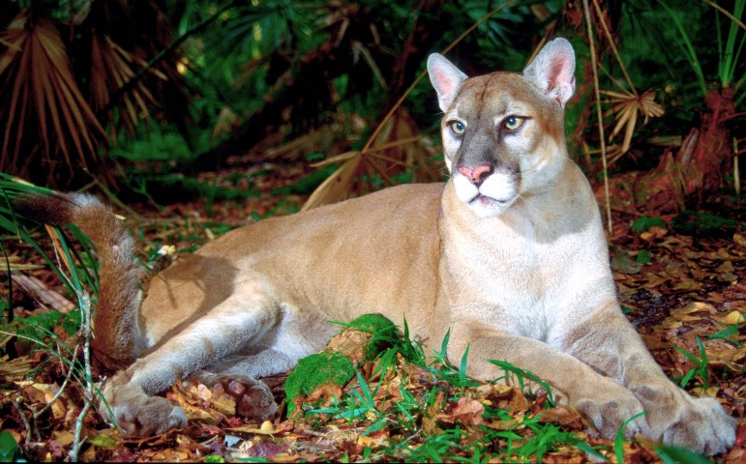A depiction of the Florida Tiger
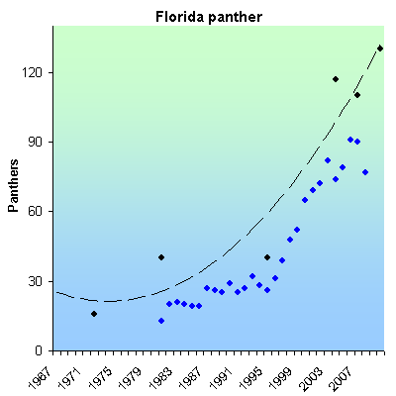
Growth of Florida Panthers after Reservation Efforts
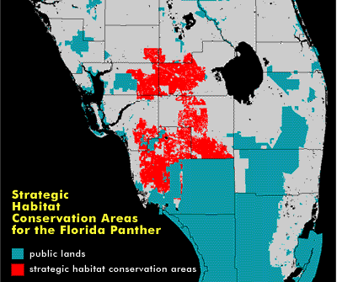
Typical Location of Florida Panthers Reserve Parks

References
Hostetler, J. A., Onorato, D. P., Jansen, D., & Oli, M. K. (2013). A cat's tale: the impact of genetic restoration on Florida panther population dynamics and persistence. Journal of Animal Ecology, 82(3), 608-620.
Lampert, A., Hastings, A., Grosholz, E. D., Jardine, S. L., & Sanchirico, J. N. (2014). Optimal approaches for balancing invasive species eradication and endangered species management. Science 344, 1028-1031.

